Graham is thrilled to be running the 2008 London Marathon in support of Free Burma Rangers

Graham and his wife Judy are passionate about the ongoing humanitarian situation inside Burma and have collaborated with the UK Charity, Christian Solidarity Worldwide (CSW) over the last 2 to 3 years to send funds out to the Free Burma Rangers ( FBR )to support their courageous aid operations out on the Thai / Burma borders.

Judy has visited and worked in the border areas on 3 occasions over the last 5 years and Graham joined her on the last 2 occasions, during which time they have built up a relationship with FBR and, in particular, a FBR team based in the Mae Sot area of Thailand, literally on the border with Burma.

Through CSW, Graham and Judy personally provide the financial support sufficient to meet the complete housing, food and clothing needs of an FBR team. In addition they raise money from friends, family and well-wishers to support the FBR central operations.

“We used to raise money to take out to the borders when we journeyed there. We paid all our own travel and lodging expenses from our own money and then friends, family and colleagues gave us additional money to distribute out there to good causes, of which there are so many in and around Burma,” says Graham. “Now that we have discovered the brave and selfless FBR, we have found the perfect way to make best use of our donations in ways which we could never match ourselves. Each year we now send the money we would otherwise spend on travel, direct to FBR. However, I can’t tell you how much we miss going there. Sometimes we ache to go back out and we increasingly talk of moving out there permanently to do what we can for the IDPs and refugees from Burma.”

Running the London Marathon now forms the main focus of fund raising for Graham and Judy in 2008.

Graham, 53, is finding the training quite challenging. “It’s been 18 months or more since Judy and I started training, because we had hoped to be selected for the 2007 London Marathon, but didn’t get in. At first, we got out of breath just pulling on our trainers!

I am not the most likely candidate for such a challenge, I must admit. I suffered from polio as a young boy and was left with sparrow’s legs and with one leg shorter than the other. I have always been a bit weedy as a result. Then, in 2001, I had a major operation on my spine to remove 2 discs and to fuse the bones together. The operation was a terrific success and saved me from the prospect of life in a wheelchair. I actually still own a wheelchair that I bought (yet thankfully never used) all those years ago. It is currently on loan to a friend from church. My knees are proving troublesome too, but determination has always been a strong characteristic of mine and nothing will deter me from finishing the London Marathon, although I have no ambitions of finishing alongside the front runners.”

I hope that my run will serve to help highlight the wonderful work of FBR and that my efforts will raise lots of money for them. My target is £4,500, but who knows?”

You can sponsor Graham by visiting:

www.justgiving.com/grahamwest

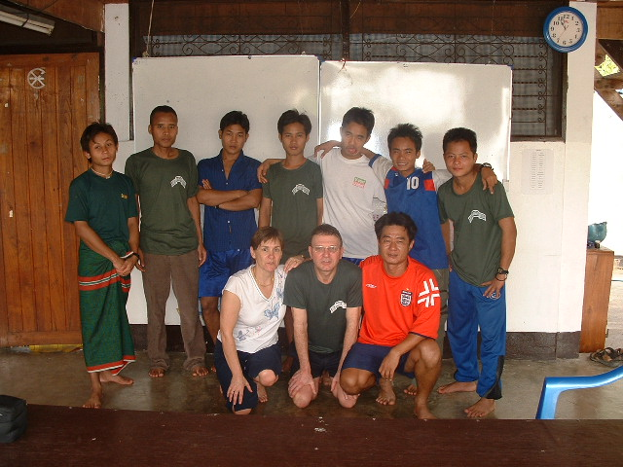

Judy and Graham with FBR team in Mae Sot 2006

